Bright day school organised spectrum volleyball tournament in which our school secured 1st place
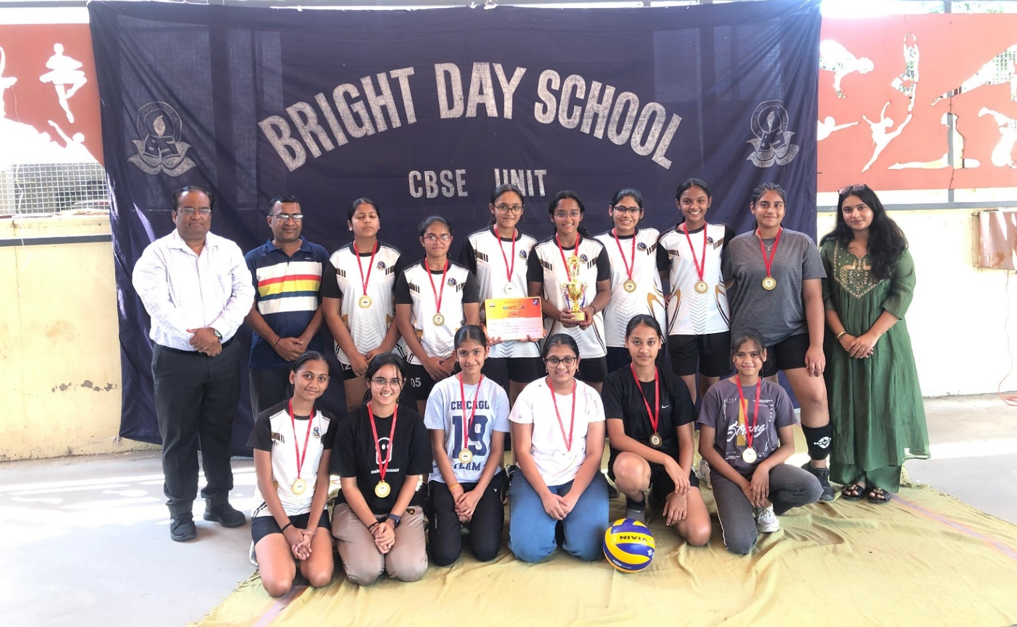
Khel Mahakumbh District level Volleyball Competition was held at the Zenit school.
Our Mother’s School
Under-17 Girls Secured 3rd position...
each student received ₹1000/- as a prize.
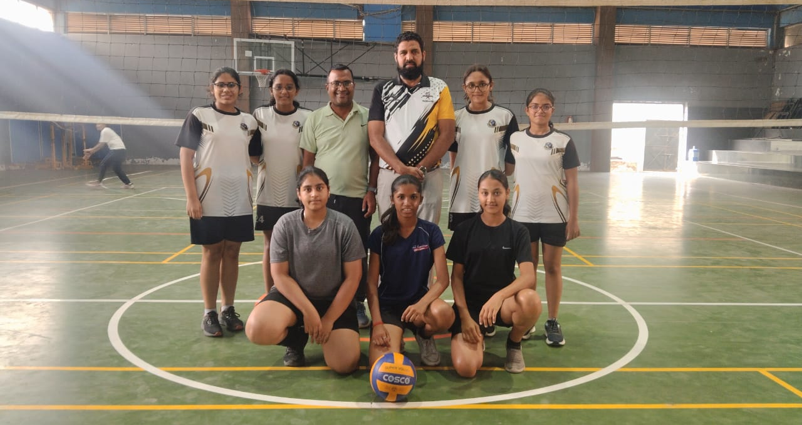

Khel Mahakumbh District level Volleyball Competition was held at the Zenit school.
Our Mother’s School
Senior Girls Secured 1st position...
each student received ₹3000/- as a prize
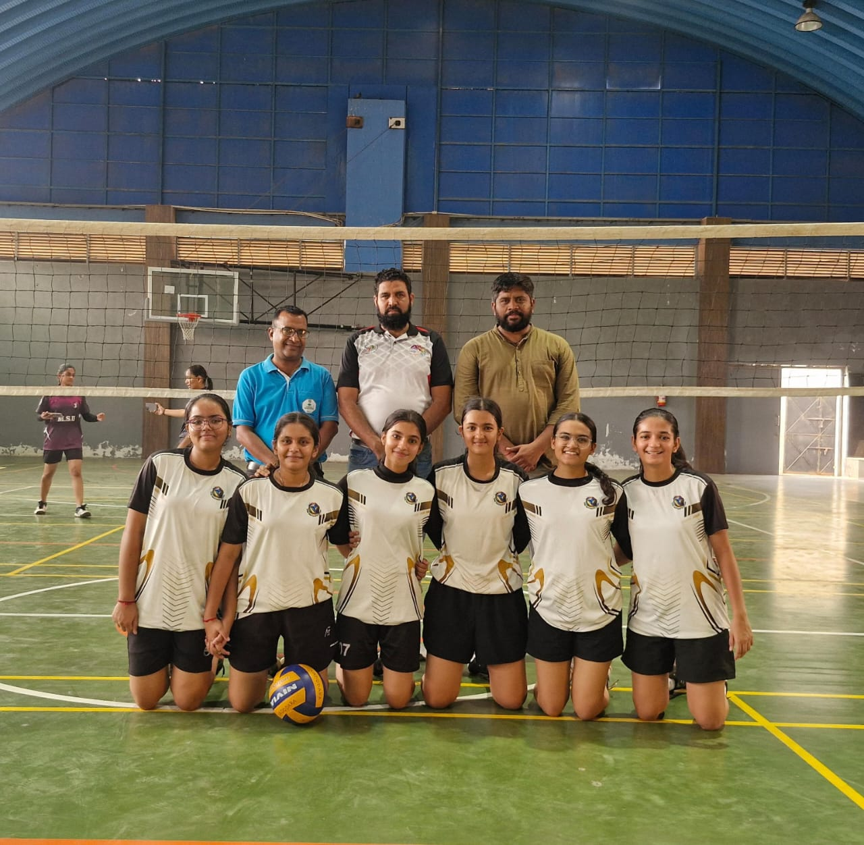

Khel Mahakumbh District level Volleyball Competition was held at the Zenit school.
Our Mother’s School
Under -14 Boys Secured 1st position...
each student received ₹3000/- as a prize.

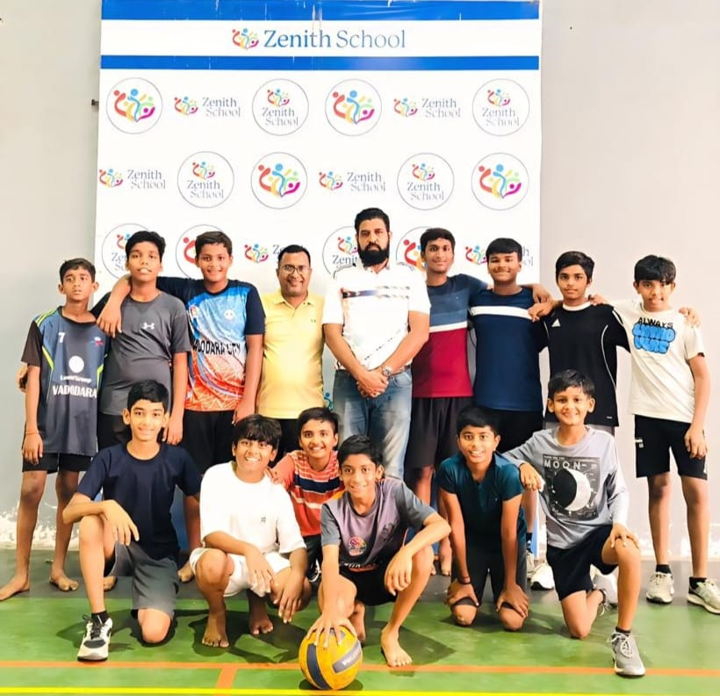

Sansad Khel organised by Dr.Hemag joshi all baroda volleyball competition at M.S.U. our 2 team under -17 & open age group Both team secured 1st position.....🥇🥇🥇
